CONTROL TOWER UPDATE-Through Mobile
- Click on Icon to update percentage progress.
  - MKTG => Marketing
  - PRJ => Projects
  - EREC => Erection
  - COMM => Commissioning
  - LOGI => Logistics
  - ESTI => Estimation

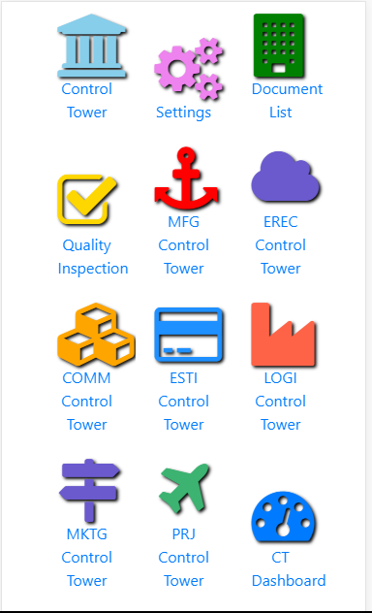
- Following Screen will appear. 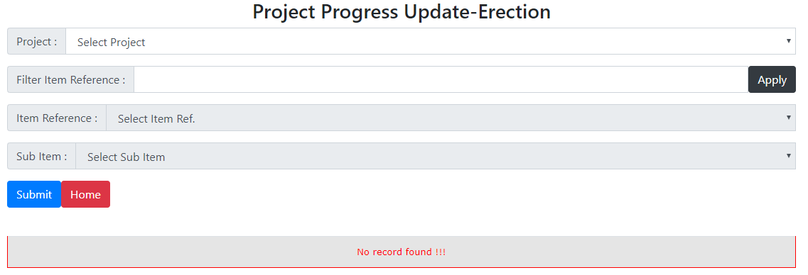
- Click on Project Dropdown List to select the Project. 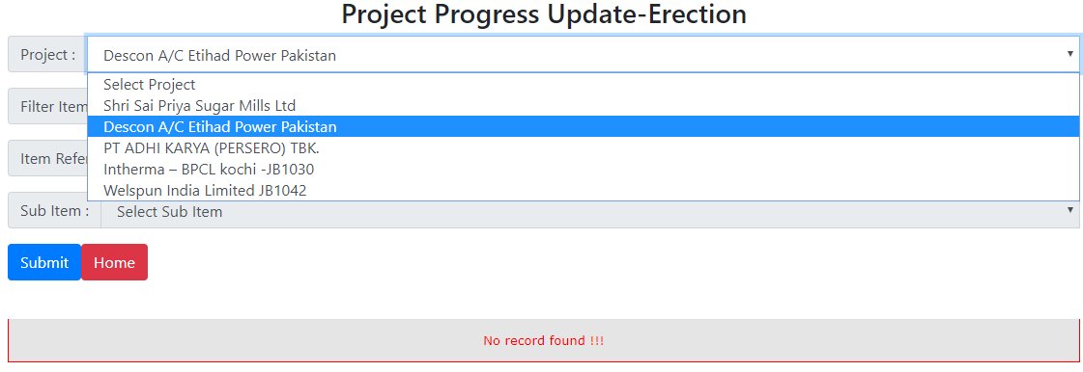
- Then in Item reference dropdown list, it will show all items of Project. To filter out Item Ref. List, Type any Key Work and click on APPLY Button. 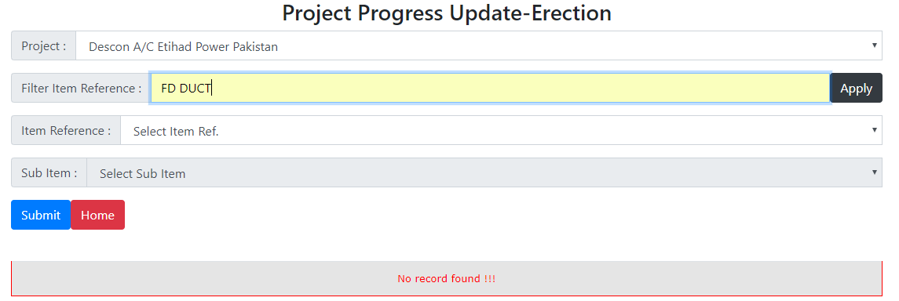
- Then in Item Reference dropdown list, It will filter out for key word entered. 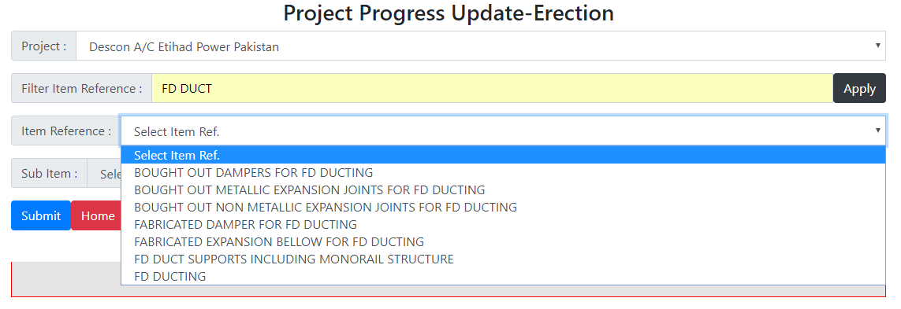
- Then in Sub. Item dropdown list, it will show the sub items. [If Item contains the sub item, select the sub Item.] 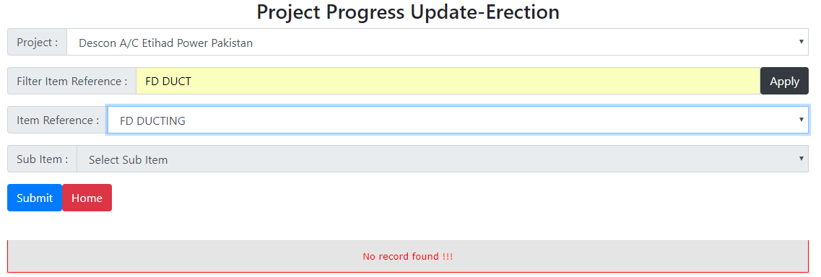
- Click on the Submit Button. It will show the list of Activities. Then click on Activity Description to enter % Progress.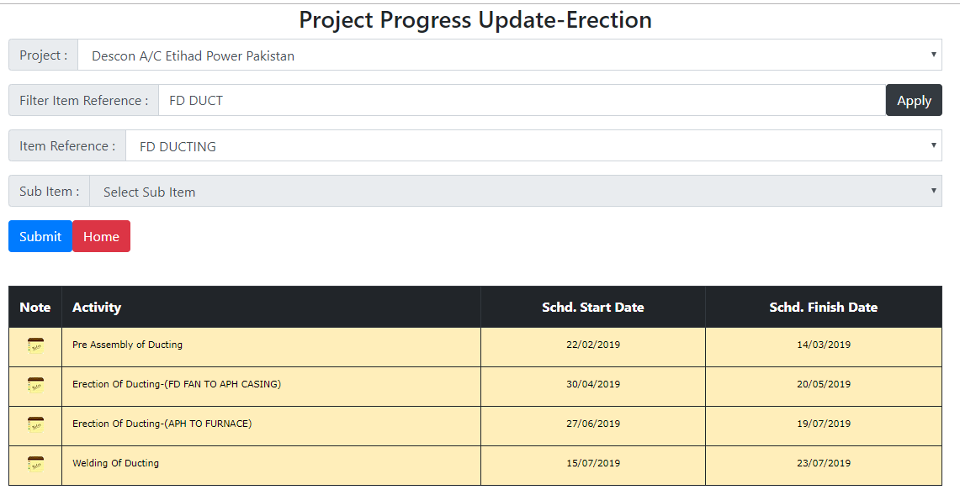
- Following Screen will appear to enter the details. 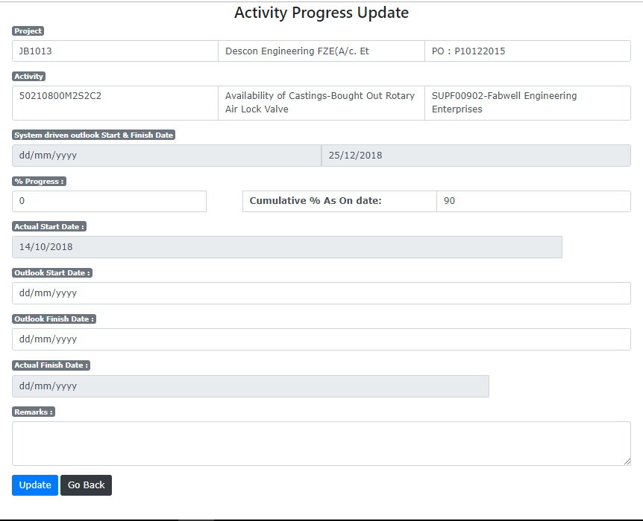
Enter % Progress here. Then click on Update button below.

